I ^{Frequently Asked Questions}

Auctions and play
Question | Answer
I want to confirm my bid or play before I make it. How do I do that? | 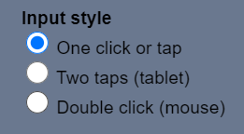  Click the Settings icon.  Now, choose “Two taps”.  This allows you to initially select a bid or play, then to confirm.  There is also a double-click option, where you make two fast clicks.
How can I ask my opponent for more information via typing? | 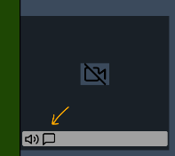  Any player can have private chat with LHO or RHO  - Click the chat icon on the grey band under the opponent’s video.  - Type into the box  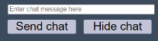  - When your conversation is complete, click Hide chat
Can I explain a bid without alerting? | Yes. Simply input the explanation, then make the bid.  There is no requirement to alert as well.  The opponents will see that there is an explanation.  The colour of the bid changes, and a balloon appears with the explanation.  Your partner does not see this.
Can I alert a bid without explaining? | Yes. Simply click Alert then make the bid.  The software doesn’t require you to add an explanation.  The players will see that there is an alert.  The colour of the bid changes.  See the Conditions of Contest for the EBL regulations.
Can I add an explanation after I have bid? | Yes. Please see the player guide for more information and screenshots.  https://realbridge.online/player-guide.html
What are the small grey buttons on the bidding box? | 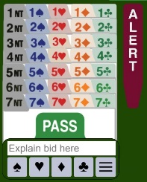  You can click the suit symbols (so, instead of typing 2+cl, then do 2+ and click the club button.  The button with 3 rows shows you the most recent explanations. To save time, choose an explanation from the list.  Please see the player guide for more information  https://realbridge.online/player-guide.html
On the Settings page, what does “Explanations” mean? | 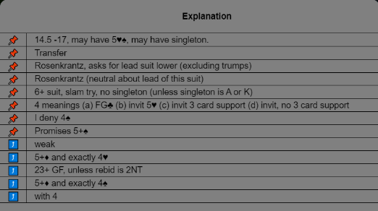  This is the same as the list that appears when you click the three dots.  You can move the more common explanations to the top of the list, so that they are easier to find.  When you bid, you can use these (see above).
When do I see the bidding box? | When it is you turn to bid.
How can I see the last trick? | 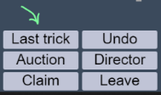  Any player can choose to see last trick, without disrupting or interfering with the current trick.  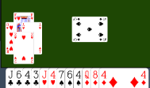  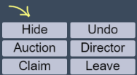  However, if they have already played to the current trick, they cannot see the last trick. This is part of the Laws.  Simply click Last trick.  A small representation of the trick appears.  Once you have finished looking at the trick, click Hide to return to the current trick.
What is the procedure to call the Director? | - Click the Director button.  - The Director will arrive, and initiate one or both of the following:  A private video call with the player(s), or talk to all players at the same time, via video.

Undo
Question | Answer
What is the process UNDO? | - The player who wants to do UNDO must click Undo  - The other players must accept or refuse

Media
Question | Answer
Why did you ask us to use the Redial button? | All voice conferencing software suffers from a degradation of quality if a call is longer than about 70 minutes. When you were in the break, the total duration of the match and the break exceeded 70 minutes.  So that you can enjoy best quality video, we ask use Redial (see icon on the right).
I cannot see my hand, what shall I do? | If using a Windows PC: do Ctrl+R, and login again.  If using a Mac: do CMD+R, and log in again.

Scores
Question | Answer
What is the best way to navigate Scores? | There are 5 things to see:  - The list of pairs and how well they are doing  - Your partnership scorecard  - Drill down to see auction and play for any board  - Board traveller (showing all scores for all pairs, for the same board).  - All pairs and their round-by-round score.  It is never more than 2 click to reach any item, from anywhere. Most of the time it is just 1 click. In this document we cannot show all the routes, but as you can see, there are many routes to all of the above.  Click the Scores button to see the scores window. Clicking it a second time closes the scores window.
This takes shows you no 1 | This is on the personal scorecard. From here clicking a number takes you to no 4. | This is on the main list of Pairs, clicking a board number opens up the traveller (no 4) | This appears on 2, 4.  Clicking the contract opens up the board to show the detail (no 3).

